***Normalization of US Bangla Airlines Management System***

Owns (Website, Airplane_No, Seating_Capacity)

1NF:

No Multivalued Attribute

2NF:

Airplane_No, Seating_Capacity, SL_No

SL_No, Website, Airplane_No

3NF:

Airplane_No, Seating_Capacity, SL_No

SL_No, Website, Airplane_No

No Transitive Dependency

**Table:**

Airplane_No, Seating_Capacity, SL_No

SL_No, Website, Airplane_No

Access (Airplane_No, Seating_Capacity, Airport_Name, Airport_Code, Address, Country, Zip, City, State)

1NF:

Address Multivalued Attribute

2NF:

Airplane_No, Seating_Capacity

Airport_Code, Address, Country, Zip, City, State

a.ID, Airplane_No, Airport_Code

3NF:

Air Airplane_No, Seating_Capacity

Airport_Code, Address, Country, Zip, City, State

a.ID, Airplane_No, Airport_Code

add_No, Address, Country, Zip, City, State

**Table:**

Air Airplane_No, Seating_Capacity

Airport_Code, Address, Country, Zip, City, State

a.ID, Airplane_No, Airport_Code

add_No, Address, Country, Zip, City, State

Has (Airplane_No, Seating_Capacity, Flight_Trip_No, Depart_Time, Arrival_Time, Arrival_Airport, Depart_Airport, No_of_Travellers)

1NF:

No Multivalued Attribute

2NF:

Airplane_No, Seating_Capacity

Flight_Trip_No, Depart_Time, Arrival_Time, Arrival_Airport, Depart_Airport,

Depart_Airport, No_of_Travellers

Af_No, Airplane_No, Flight_Trip_No

3NF:

Airplane_No, Seating_Capacity

Flight_Trip_No, Depart_Time, Arrival_Time, Arrival_Airport, Depart_Airport,

Depart_Airport, No_of_Travellers

Af_No, Airplane_No, Flight_Trip_No

No Transitive Dependency

**Table:**

Airplane_No, Seating_Capacity

Flight_Trip_No, Depart_Time, Arrival_Time, Arrival_Airport, Depart_Airport,

Depart_Airport, No_of_Travellers

Af_No, Airplane_No, Flight_Trip_No

Cost (Flight_Trip_No, Depart_Time, Arrival_Time, Arrival_Airport, Depart_Airport, No_of_Travellers, Discount, Amount, Tax, Currency, Final_Amount)

1NF:

No Multivalued Attribute

2NF:

Flight_Trip_No, Depart_Time, Arrival_Time, Arrival_Airport, Depart_Airport,

No_of_Travellers, f_No

F_No, Discount, Amount, Tax, Currency, Final_Amount

3NF:

Flight_Trip_No, Depart_Time, Arrival_Time, Arrival_Airport, Depart_Airport,

No_of_Travellers, f_No

F_No, Discount, Amount, Tax, Currency, Final_Amount

No Transitive Dependency

**Table:**

Flight_Trip_No, Depart_Time, Arrival_Time, Arrival_Airport, Depart_Airport,

No_of_Travellers, f_No

F_No, Discount, Amount, Tax, Currency, Final_Amount

Travels (Flight_Trip_No, Depart_Time, Arrival_Time, Arrival_Airport, Depart_Airport, No_of_Travellers, Phone, Traveller_ID, Name, First_Name, Last_Name)

1NF:

Phone multivalued Attribute

2NF:

Flight_Trip_No, Depart_Time, Arrival_Time, Arrival_Airport, Depart_Airport,

No_of_Travellers

Traveller_ID, Name, Phone, First_Name, Last_Name, Flight_Trip_No

3NF:

Flight_Trip_No, Depart_Time, Arrival_Time, Arrival_Airport, Depart_Airport,

No_of_Travellers

Traveller_ID, Phone, Flight_Trip_No, n_No

n_No, Name, First_Name, Last_Name

**Table:**

Flight_Trip_No, Depart_Time, Arrival_Time, Arrival_Airport, Depart_Airport,

No_of_Travellers

Traveller_ID, Phone, Flight_Trip_No, n_No

n_No, Name, First_Name, Last_Name

Reserved (Phone, Traveller_ID, Name, First_Name, Last_Name, Seat_No, Available, Location, Class)

1NF:

Phone Multivalued Attribute

2NF:

Traveller_ID, Name, First_Name, Last_Name

Seat_No, Available, Location, Class, Traveller_ID

3NF:

Traveller_ID, Name, First_Name, Last_Name

Seat_No, Available, Location, Class, Traveller_ID

No Transitive Dependency

**Table:**

Traveller_ID, Name, First_Name, Last_Name

Seat_No, Available, Location, Class, Traveller_ID

Has (Airplane_No, Seating_Capacity, Seat_No, Available, Location, Class)

1NF:

No Multivalued Attribute

2NF:

Airplane_No, Seating_Capacity

Seat_No, Available, Location, Class, Airplane_No

3NF:

Airplane_No, Seating_Capacity

Seat_No, Available, Location, Class, Airplane_No

No Transitive Dependency

**Table:**

Airplane_No, Seating_Capacity

Seat_No, Available, Location, Class, Airplane_No

**Total Table:**

Airplane_No, Seating_Capacity, SL_No

SL_No, Website, Airplane_No

~~Air Airplane_No, Seating_Capacity~~

Airport_Code, Address, Country, Zip, City, State

a.ID, Airplane_No, Airport_Code

add_No, Address, Country, Zip, City, State

~~Airplane_No, Seating_Capacity~~

~~Flight_Trip_No, Depart_Time, Arrival_Time, Arrival_Airport, Depart_Airport,~~

~~No_of_Travellers~~

Af_No, Airplane_No, Flight_Trip_No

~~Flight_Trip_No, Depart_Time, Arrival_Time, Arrival_Airport, Depart_Airport,~~

~~No_of_Travellers, f_No~~

F_No, Discount, Amount, Tax, Currency, Final_Amount

Flight_Trip_No, Depart_Time, Arrival_Time, Arrival_Airport, Depart_Airport,

No_of_Travellers

Traveller_ID, Phone, Flight_Trip_No, n_No

n_No, Name, First_Name, Last_Name

Traveller_ID, Name, First_Name, Last_Name

Seat_No, Available, Location, Class, Traveller_ID

~~Airplane_No, Seating_Capacity~~

Seat_No, Available, Location, Class, Airplane_No

**Final Table:**

Airplane_No, Seating_Capacity, SL_No

SL_No, Website, Airplane_No

Airport_Code, Address, Country, Zip, City, State

a.ID, Airplane_No, Airport_Code

add_No, Address, Country, Zip, City, State

Af_No, Airplane_No, Flight_Trip_No

F_No, Discount, Amount, Tax, Currency, Final_Amount

Flight_Trip_No, Depart_Time, Arrival_Time, Arrival_Airport, Depart_Airport,

No_of_Travellers

Traveller_ID, Phone, Flight_Trip_No, n_No

n_No, Name, First_Name, Last_Name

Traveller_ID, Name, First_Name, Last_Name

Seat_No, Available, Location, Class, Traveller_ID

Seat_No, Available, Location, Class, Airplane_No

**Description of all table:**

**US_BANGLA table:**

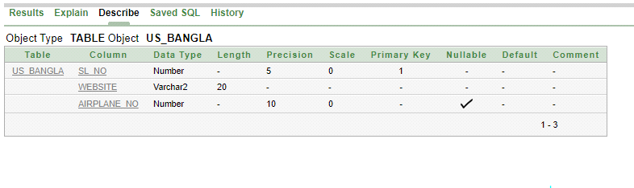

**Airplane Table:**

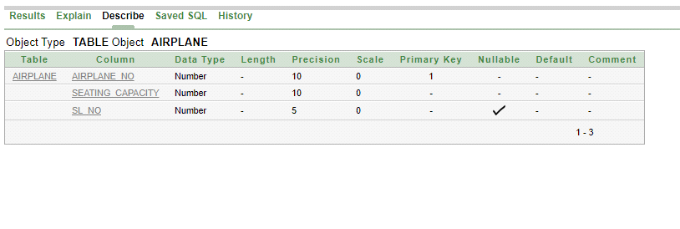

**US_BANGLA table:**

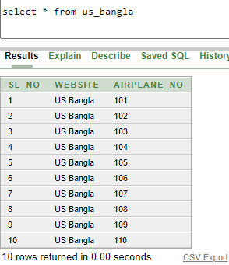

**Airplane table:**

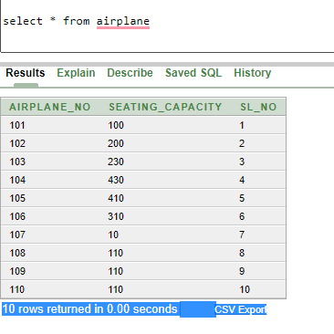

**Airport Table:**

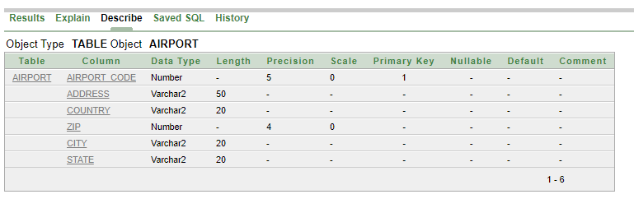

**Airport Location Table:**

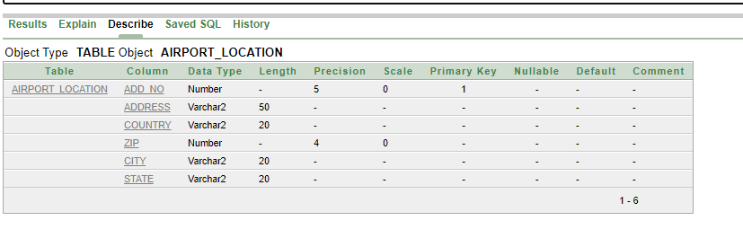

**Airport Table:**

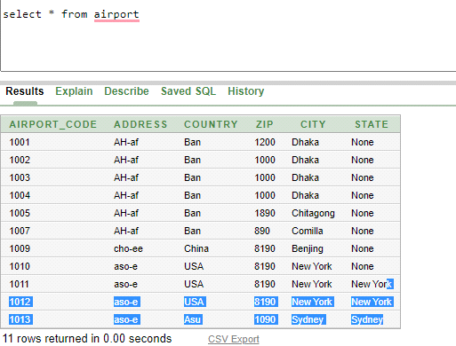

**Airport Table:**

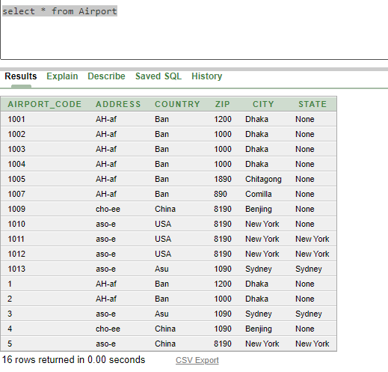

**Airport Location Table:**

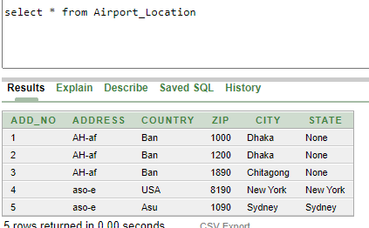

**Airport Details Table:**

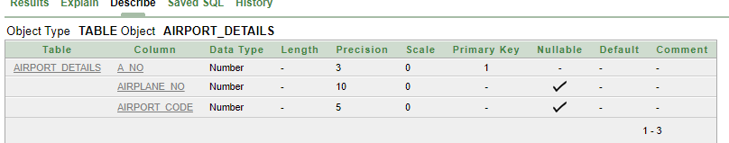

**Flight Trip Table:**

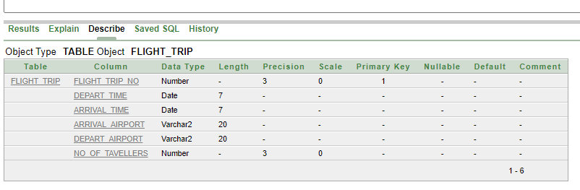

**Airport Deatils Table:**

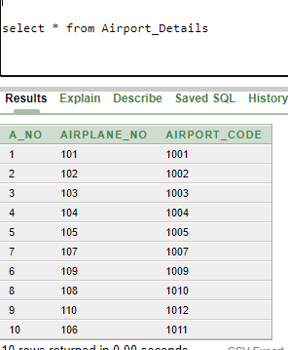

**Flight Trip Table:**

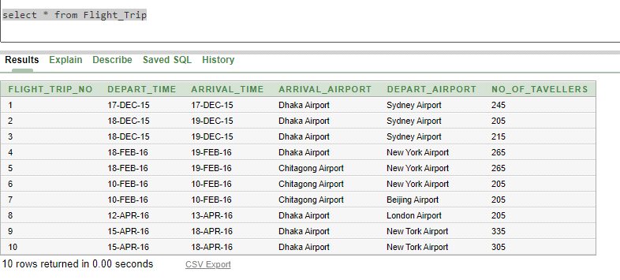

**Flight Details Table:**

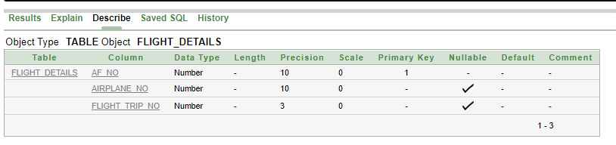

**Flight Details Table:**

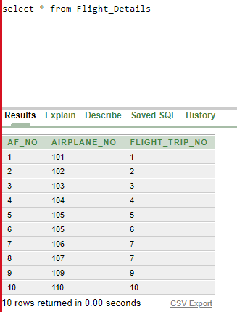

**Traveler_Name Details Table:**

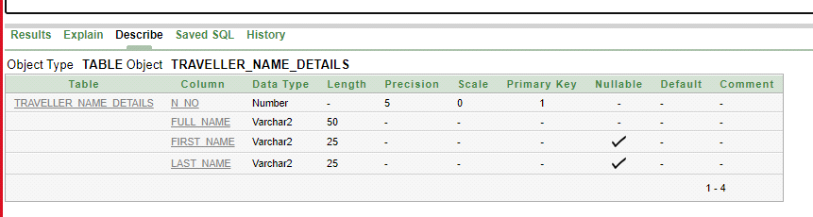

**Traveller Name Details Table:**

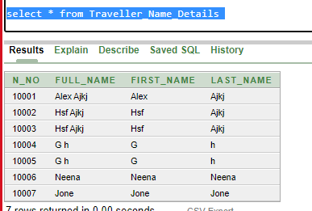

**Fare Table:**

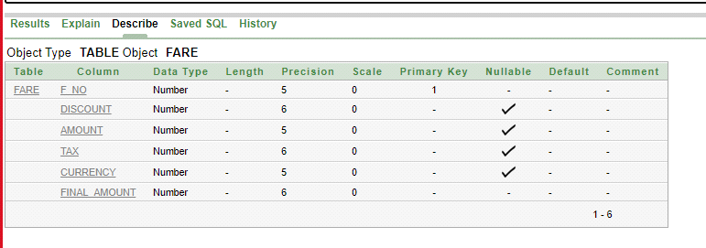

**Traveller Details:**

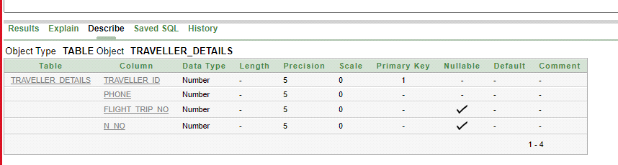

**Fare Table:**

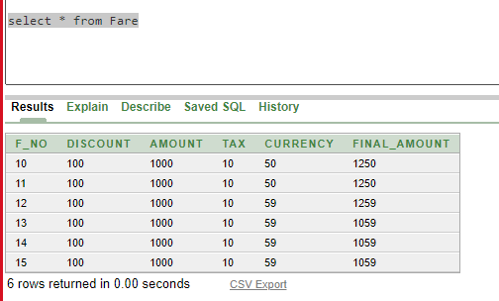

**Traveller Details:**

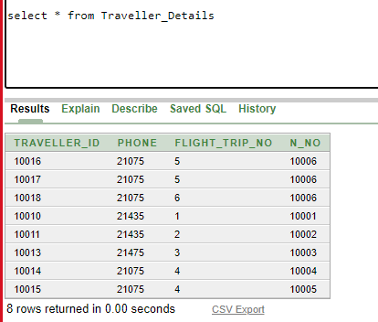

**Traveller Table:**

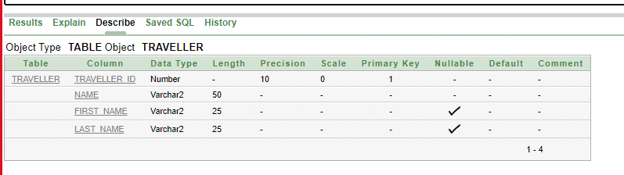

**Traveller Seat Details Table:**

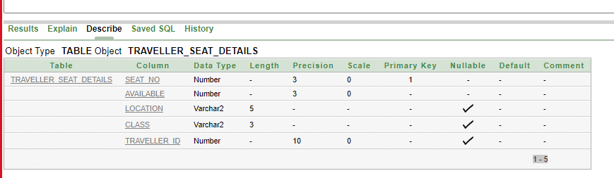

**Traveller Table:**

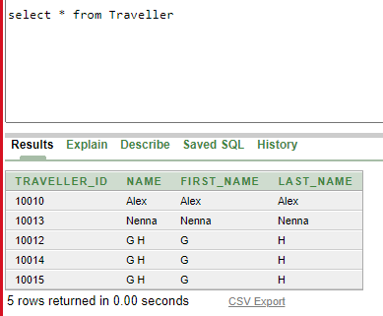

**Seats Table:**

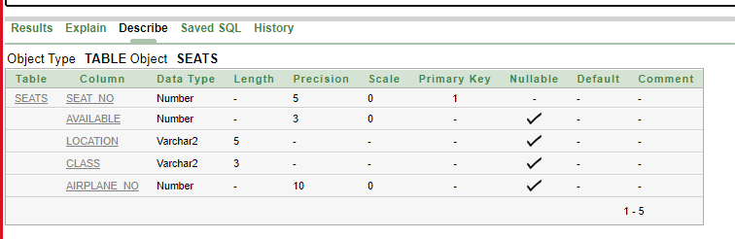

**Traveller Seat Details Table:**

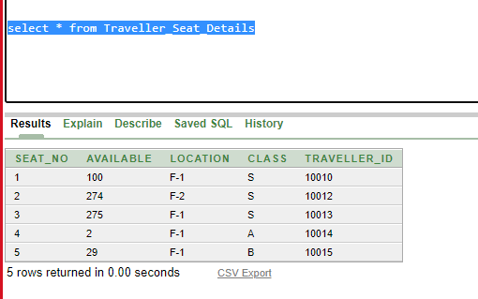

**Seats Tabel:**

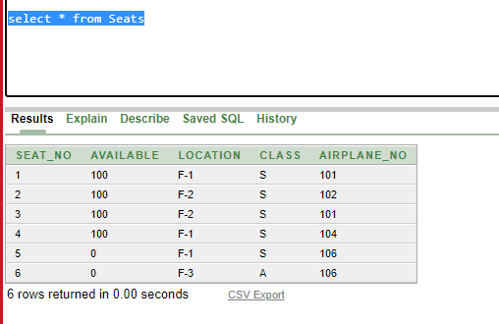

***Table SQL***

**1.**

create table Airplane(

Airplane_No number(10) primary key,

Seating_Capacity number(10) not null,

SL_No number(5) constraint sl_usfk references US_Bangla(SL_No))

insert into Airplane(Airplane_No, Seating_Capacity, SL_No) values (110, 110, 01)

select * from airplane

**2.**

create table US_Bangla(

SL_No number(5) not null primary key,

Website varchar2(20) not null,

Airplane_No number(10))

insert into US_Bangla(SL_No, Website, Airplane_No) values (10, 'US Bangla', 110)

select * from us_bangla

drop table airplane

drop table us_bangla

desc us_bangla

desc airplane

**3.**

create table Airport(

Airport_code number(5) not null primary key,

Address varchar2(50) not null,

Country varchar2(20) not null,

Zip number(4) not null,

City varchar2(20) not null,

State varchar2(20) not null)

desc airport

Insert into Airport(Airport_code, Address, Country, Zip, City, State) values(1001, 'AH-af', 'Ban', 1200, 'Dhaka', 'None')

Insert into Airport(Airport_code, Address, Country, Zip, City, State) values(1013, 'aso-e', 'Asu', 1090, 'Sydney', 'Sydney')

select * from airport

**4.**

create table Airport_Location(

Add_No number(5) not null primary key,

Address varchar2(50) not null,

Country varchar2(20) not null,

Zip number(4) not null,

City varchar2(20) not null,

State varchar2(20) not null)

desc Airport_Location

Insert into Airport_Location(add_no, Address, Country, Zip, City, State) values(03, 'AH-af', 'Ban', 1890, 'Chitagong', 'None')

Insert into Airport_Location(add_no, Address, Country, Zip, City, State) values(05, 'aso-e', 'Asu', 1090, 'Sydney', 'Sydney')

select * from Airport_Location

**5.**

create table Airport_Details(

a_No number(3) not null primary key,

Airplane_No number(10) constraint an_ap_fk references Airplane(Airplane_No),

Airport_code number(5) constraint ac_ad_fk references Airport(Airport_code))

desc Airport_Details

drop table Airport_Details

Insert into Airport_Details(a_No, airplane_no, airport_code) values (10, 106, 1011)

select * from Airport_Details

**6.**

create table Flight_Trip(

Flight_Trip_No number(3) not null primary key,

Depart_Time date not null,

Arrival_Time date not null,

Arrival_Airport varchar2(20) not null,

Depart_Airport varchar2(20) not null,

No_of_Tavellers number(3) not null)

drop table Flight_Trip

desc Flight_Trip

insert into Flight_Trip(Flight_Trip_No, Depart_Time, Arrival_Time, Arrival_Airport, Depart_Airport, No_of_Tavellers) values (10,TO_DATE('15/04/2016', 'DD/MM/YYYY'),TO_DATE('18/04/2016', 'DD/MM/YYYY'), 'Dhaka Airport', 'New Tork Airport', 305)

select * from Flight_Trip

**7.**

create table Flight_Details(

Af_No number(10) not null primary key,

Airplane_No number(10) constraint an_app_fk references Airplane(Airplane_No),

Flight_Trip_No number(3) constraint fn_ft_fk references Flight_Trip(Flight_Trip_No))

desc Flight_Details

Insert into Flight_Details(Af_No, Airplane_No, Flight_Trip_No) values(10, 110, 10)

select * from Flight_Details

**8.**

create table Traveller_Name_Details(

n_No number(5) primary key,

Full_Name varchar2(50) not null,

First_name varchar2(25),

Last_Name varchar2(25))

desc Traveller_Name_Details

drop table Traveller_Name_Details

Insert into Traveller_Name_Details(n_No, Full_Name, First_Name, Last_NAMe) values (10007, 'Jone', 'Jone', 'Jone')

select * from Traveller_Name_Details

**9.**

create table Fare(

F_No number(5) primary key,

Discount number(6),

Amount number(5),

Tax number(6),

Currency number(5),

Final_Amount number(6) not null)

desc Fare

Insert into Fare(F_No, Discount, Amount, Tax, Currency, Final_Amount) values (0015, 100, 1000, 10, 59, 1059)

select * from Fare

**10.**

create table Traveller_Details(

Traveller_ID number(5) primary key,

Phone number(5) not null,

Flight_Trip_No number(5) constraint fi_fi_fk references Flight_Trip(Flight_Trip_No),

n_No number(5) constraint tr_fn_fk references Traveller_Name_Details(n_No))

desc Traveller_Details

drop table Traveller_Details

insert into Traveller_Details(Traveller_ID, Phone, Flight_Trip_No, n_No) values (10019, 11075, 07, 10008)

select * from Traveller_Details

**11.**

create table Traveller(

Traveller_ID number(10) primary key,

Name Varchar2(50) not null,

First_Name varchar2(25),

Last_Name varchar2(25))

desc Traveller

insert into Traveller(Traveller_ID, Name, First_Name, Last_Name) values (10015, 'G H', 'G','H')

select * from Traveller

**12.**

CREATE TABLE Traveller_Seat_Details(

Seat_No number(3) primary key,

Available number(3) not null,

Location Varchar2(5),

Class varchar2(3),

Traveller_ID number(10) constraint ti_ffn_fk references Traveller(Traveller_ID ))

desc Traveller_Seat_Details

insert into Traveller_Seat_Details(Seat_No, Available, Location, Class, Traveller_ID) values (05, 29, 'F-1', 'B', 10015)

select * from Traveller_Seat_Details

**13.**

create table Seats(

Seat_No number(5) primary key,

Available number(3),

Location varchar2(5),

Class varchar2(3),

Airplane_No number(10) constraint a_ap_fk references Airplane(Airplane_No))

desc Seats

Insert into Seats(Seat_No, Available, Location, Class, Airplane_No) values (06, 00, 'F-3', 'A', 106)

select * from Seats

**Questions for query:**

1.display state,city,zip,country,address where airport code=1012

2.display traveller id,phone,n no where flight trip no=5

3.display discount,amount,tax,currency,final amount where f no=12

4.display maximum available seat where class=s

5.display full name where first name='alex'

6.display airplane no,serial no where seat capacity more than 200

7.display flight trip no,departure time,arrival time,depart airport for those airplane which have more than 250 traveller

8.Write a SQL statement to prepare a list with traveller id, airplane no and their class for the traveller id and airplane no who belongs to the same class

9.Write a query to create a view for those airport code belongs to the city dhaka

10.Write a query to create a view for those traveller id belongs to the 5 no. flight trip

**Query:**

display state,city,zip,country,address where airport code=1012

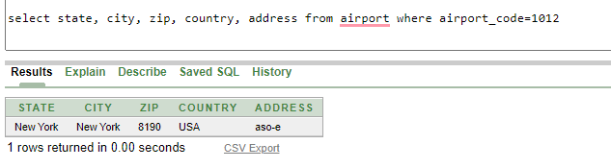

display traveller id,phone,n no where flight trip no=5

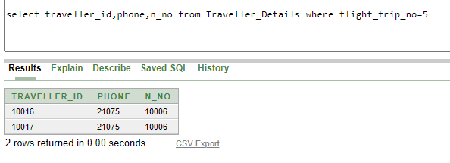

display discount,amount,tax,currency,final amount where f no=12

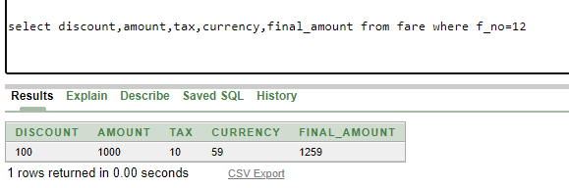

display maximum available seat where class=s

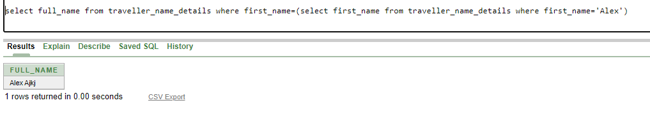

display full name where first name='alex'

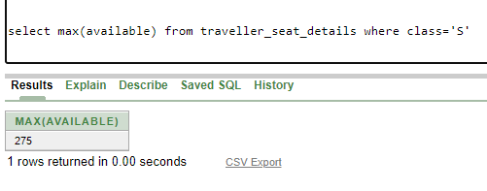

display airplane no,serial no where seat capacity more than 200

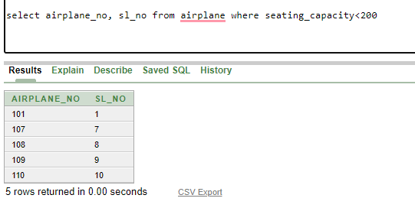

display flight trip no,departure time,arrival time,depart airport for those airplane which have more than 250 traveller

